Hitters Data Analysis

William Arnost, Daniel Crouthamel, Richard Palmer

# Introduction

The goal of this analysis is to determine which baseball performance metrics influence a player’s salary. We will conduct a modeling exercise to see which features are useful in predicting salary and test different modeling techniques. We will also perform a two way anova analysis to determine the effect of league and division on salary.

# Data Description

This data set contains salary information and career statistics for major league baseball players. The salary data was original from Sports Illustrated (April 20, 1987) while the career statistics are from the 1987 Baseball Encyclopedia Update published by Collier Books. We sourced the data from Kaggle (<https://www.kaggle.com/floser/hitters>) and it is also used in the ISLR R-package and is used in the textbook "An Introduction to Statistical Learning with applications in R" by G. James et al. (2013).

The data contains 322 observations, 1 per player, and 20 variables. The variables include salary and career statistics like Home Runs, times At Bat, Errors, and others.

# Exploratory Data Analysis

The salary variable will the response variable for modeling, so let’s look at that first. A quick summary shows that the minimum salary is $67.5K and the maximum is $2.46M. There are 59 NA values in the salary variable, so we will need to exclude those values for modeling (About 18% of the dataset).

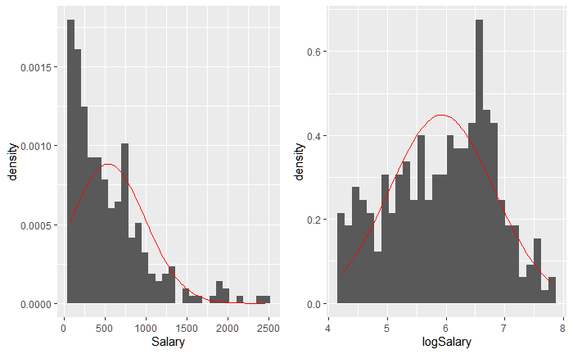

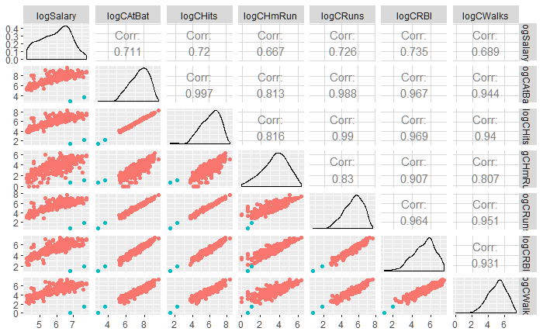The two figures to the right are the histograms of Salary and logSalary respectively. We can see in the first histogram that Salary, untransformed, is very right skewed, with the maximum salary being almost 6x the median salary. We will need to transform the variable for modeling to deal with non-normality in the residuals.

Next, we look at a pairs plot to the left with logSalary and logged career statistics, which we transformed for similar reasons to salary. We see positive correlation with each of these variables compared to salary, and we can see that they have pretty strong correlation with each other. We will need to check for multicollinearity in our model. We also identified two players who seem consistently out of place (colored in teal).

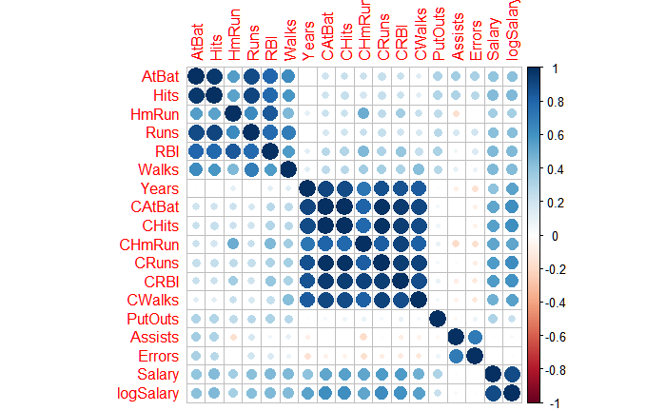

The correlation matrix to the right shows how in season statistics are related to each other strongly, and career statistics are related to each other strongly. However, in season and career statistics are not strongly correlated. Put Outs, Assists, and Errors do not seem to have a relationship with salary.

# Objective 1: Modeling

## Problem Statement

We would like to know which career statistics are indicative of a player’s salary. We will use a predictive model to assess which statistics, if any, are important. We will use variable selection techniques to help fit the best model.

## Model Selection

For model selection, we will compare four different possibilities in R, these being Least Squares, Ridge, Lasso and Elastic net. Additionally, we will perform an additional Lasso test in SAS for comparison. As mentioned above, logging salary seems to be appropriate. It also appears that logging the career attributes, those that start with C, will also be beneficial. Notice below that the scatter plots (far left column) is more linear with the right graph using log of C* attributes. The residual plots using SAS in the last row show a more uniform cloud distribution.

|  |  |
| --- | --- |
|  |  |
|  |  |

## Assumption Checking

For the purpose of assumption checking, the Lasso model was used (see Comparing Competing Models). All models performed roughly the same, but since Lasso has fewer parameters, we opted for the simpler model.

The Residual vs Predicted (bottom right) is roughly a cloud shape around 0 and the QQ plot shows that the residuals are somewhat normally distributed, although there are few significant outliers.

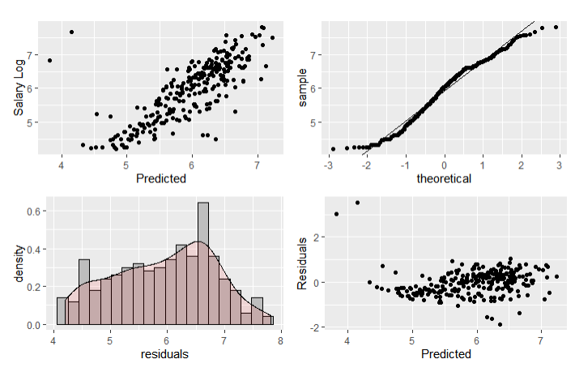

## Compare Competing Models

We performed a comparison between 4 different models and the mean RMSE value was nearly the same all 4. Lasso was selected because it resulted in the least number of coefficients, thereby producing a simpler, easier to explain model.

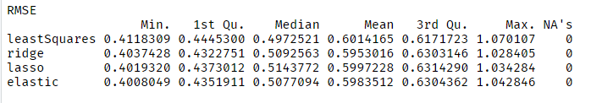

<ADD IN SAS Analysis>

## Parameter Interpretation

### Interpretation

### Confidence Intervals

## Final Conclusions for Objective 1

# Objective 2: Advanced Analysis

## State the method

We will conduct a Two Way ANOVA test to see if there is a difference in mean salary when considering the League and Division of a player.

## Main Analysis Content

First, we looked at the means plot in the top left figure. The means are only slightly different for the National League across divisions. The American league shows a larger difference in log Salary, which is higher than the National league in the East division but below it in the West Division. There might be a non-additive relationship here.

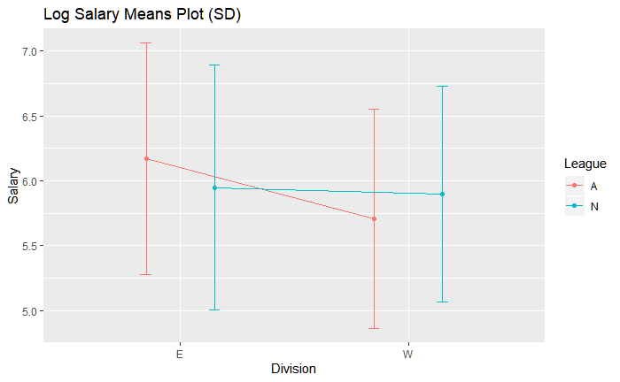

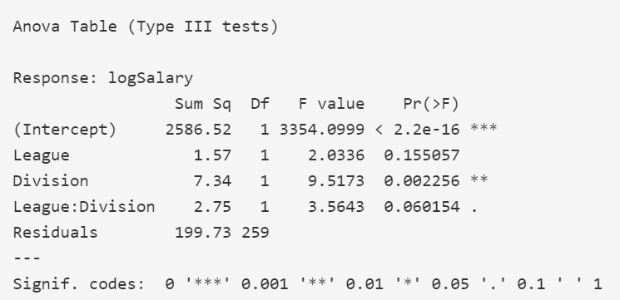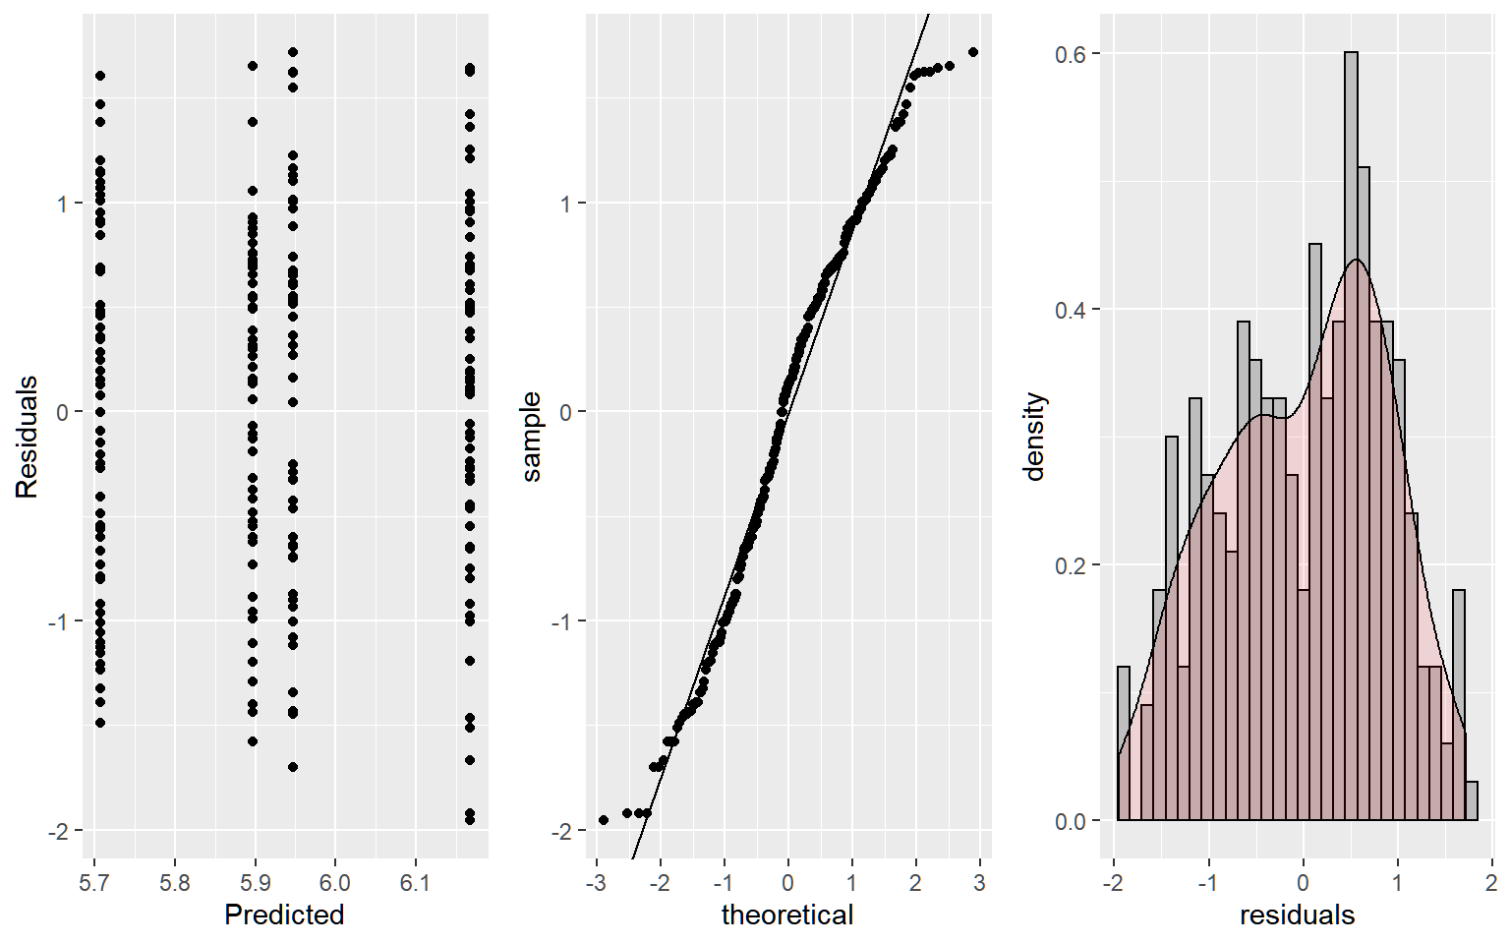

The diagnostics of the logSalary model look good, the residuals are mostly normal and variance appears constant. The observations are independent in that players in one League or Division cannot appear in another, but this deserves more discussion later. Looking at the F-Tests, Division is significant, and the interaction term just barely fails the F-Test. As a result, we will consider this an additive model and focus on the differences in Division since it was the only significant factor.

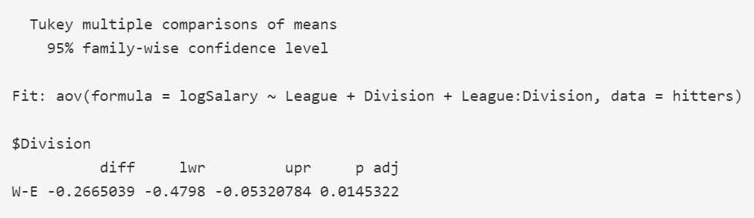

There is evidence that logSalary is different between the East and West Division (p-value 0.0145). If we look at both league and division, it seems the E-W difference is only present in the American League.

## Conclusion / Discussion

Using a two way anova analysis we found that there was a difference in median salary between the east and west division. We did not find evidence that there was a difference in median salary between the American and National leagues, and also that there was not enough evidence to support an interaction between league and division.

Regarding independence of observations, there are some subtleties beyond whether players not being present in multiple divisions. If a team is losing, their innings end quicker, and everyone on that team probably takes a hit to statistics like at bats and hits. Also, salaries may be correlated among players on the same team. Unfortunately we don’t have player names, positions, or teams in this data set to look if we are still ok to assume independence. We are assuming these don’t have a major impact on our tests.

# Appendix

## Well Documented Code

## Summary Graphics and Tables